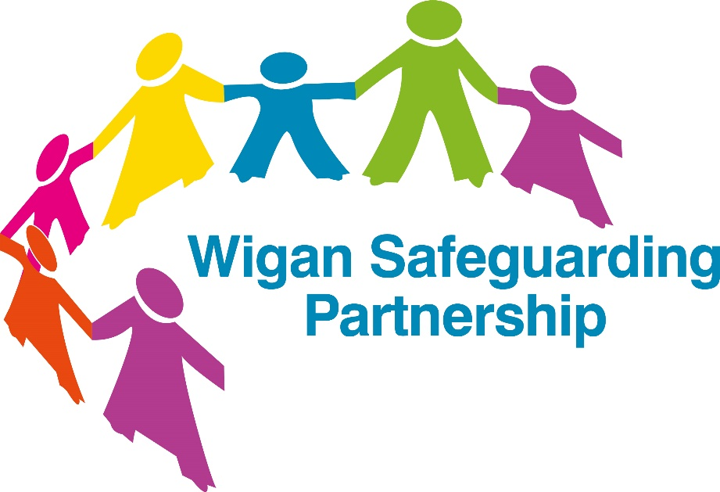

Template

Children’s Safeguarding Policy for Community
& Voluntary Groups

Children’s Safeguarding Policy for (insert organisation/group name)

This is a policy template for community groups which contains reference to procedures. The template must be amended to meet the requirements of your organisation and to ensure that it is consistent with current legislation and good practice guidance. It should be read alongside your own organisation’s safeguarding procedures.

Once this document has been finalised within your organisation it needs to be agreed at the governance level within your organisation and cascaded to everyone in to ensure all employees, trustees and volunteers know their responsibilities in terms of safeguarding children who access the community group.

[organisation name] abides by the duty of care to safeguard and promote the welfare of children and young people and is committed to safeguarding practice that reflects statutory responsibilities, government guidance and complies with best practice requirements.
- We recognise the welfare of children is paramount in all the work we do and in all the decisions we take
- All children, regardless of age, disability, gender reassignment, race, religion or belief, sex, or sexual orientation has an equal right to protection from all types of harm or abuse
- Some children are additionally vulnerable because of the impact of previous experiences, their level of dependency, communication needs or other issues
- Working in partnership with children, young people, their parents, carers and other agencies is essential in promoting young people’s welfare.

Purpose:
[organisation name] will:
- Protect children and young people who receive [name of group/organisation]’s services
- from harm. This includes the children of adults who use our services
- Provide staff and volunteers, as well as children and young people and their families, with the overarching principles that guide our approach to child protection.
This policy applies to anyone working on behalf of [organisation name], including senior managers and the board of trustees, paid staff, volunteers, sessional workers, agency staff and students. Failure to comply with the policy and related procedures will be addressed without delay and may ultimately result in dismissal/exclusion from the organisation.

Definitions:
The Children Act 1989 definition of a child is: anyone who has not yet reached their 18th birthday, even if they are living independently, are a member of the armed forces or is in hospital.

Adult at Risk:
- An adult who has needs for care and support (whether or not the authority is meeting any of those needs),
- is experiencing, or is at risk of, abuse or neglect, and
- as a result of those needs is unable to protect himself or herself against the abuse or neglect or the risk of it.

Child and Adult Abuse: Children and adults may be vulnerable to neglect and abuse or exploitation from within their family and from individuals they come across in their daily lives. There are 4 main categories of abuse, which are: sexual, physical, emotional abuse, and neglect. It is important to be aware of more specific types of abuse that fall within these categories, they are:
- Bullying and cyberbullying
- Child sexual exploitation
- Child Criminal exploitation
- Child trafficking
- Domestic abuse
- Female genital mutilation
- Grooming
- Historical abuse
- Online abuse

Safeguarding children: Safeguarding children is defined in Working Together to Safeguard Children 2018 as:
- protecting children from maltreatment.
- preventing impairment of children’s health or development.
- ensuring that children are growing up in circumstances consistent with the provision of safe and effective care.
- taking action to enable all children to have the best outcomes.
Safeguarding as Part of the Deal:
In safeguarding children, [organisation name] is committed to the principles to the Wigan Borough Deal. (https://www.wigan.gov.uk/Council/The-Deal/The-Deal.aspx)

Legal Framework:
This policy has been drawn up on the basis of legislation, policy and guidance that seeks to protect children in England. A summary of the key legislation is available from nspcc.org.uk/learning.

[organisation name] should have in place arrangements that reflect the importance of safeguarding and promoting the welfare of children and young people as well as vulnerable adults.

The Prevent duty
Some organisations in England, Scotland and Wales have a duty, as a specified authority under section 26 of the Counterterrorism and Security Act 2015, to identify vulnerable children and young people and prevent them from being drawn into terrorism. This is known as the Prevent duty. These organisations include:
- Schools
- Registered childcare providers
- Local authorities
- Police
- Prisons and probation services
- NHS trusts and foundations.
- Other organisations may also have Prevent duties if they perform delegated local authority functions.
Children can be exposed to different views and receive information from various sources. Some of these views may be considered radical or extreme.

Radicalisation is the process through which a person comes to support or be involved in extremist ideologies. It can result in a person becoming drawn into terrorism and is in itself a form of harm.

Extremism is vocal or active opposition to fundamental British values, including democracy, the rule of law, individual liberty and mutual respect and tolerance of different faiths and beliefs.

Training and Awareness:
[organisation name] will ensure an appropriate level of safeguarding training is available to its Trustees, Employees, Volunteers and any relevant persons linked to the organisation who requires it (e.g. contractors).
For all employees who are working or volunteering with children, this requires them as a minimum to have awareness training that enables them to:
- Understand what safeguarding is and their role in safeguarding children.
- Recognise an child potentially in need of safeguarding and take action.
- Understand how to report a safeguarding Alert.
- Understand dignity and respect when working with children.
- Have knowledge of the Safeguarding Children Policy.

Wigan Safeguarding Partnership provides free safeguarding training for community groups from http://wigansafeguardingadults.org/Professionals/Professional-training.aspx

Similarly, employees and volunteers may encounter concerns about the safety and wellbeing of an adult at risk of abuse. For more information about adults safeguarding, refer to [organisation name] Adults Safeguarding Policy.

Confidentiality and Information Sharing:
[organisation name] expects all employees, volunteers and trustees to maintain confidentiality. Information will only be shared in line with the General Data Protection Regulations (GDPR) and Data Protection.

However, information should be shared with the Local Authority if a child is deemed to be at risk of harm or contact the police if they are in immediate danger, or a crime has been committed. For further guidance on information sharing and safeguarding see (name of Confidentiality and Information Sharing policies].

Recording and Record Keeping:
A written record must be kept about any concern regarding an adult with safeguarding needs. This must include details of the person involved, the nature of the concern and the actions taken, decision made and why they were made.

All records must be signed and dated. All records must be securely and confidentially stored in line with General Data Protection Regulations (GDPR). [name of procedures on record keeping]

Safe Recruitment & Selection:
[organisation name] is committed to safe employment and safe recruitment practices, that reduce the risk of harm to children from people unsuitable to work with them or have contact with them.

[organisation name] has policies and procedures that that cover the recruitment of all Trustees, employees and volunteers. [name of safe recruitment and selection procedures and code of conduct].

Social Media:
All employees and volunteers should be aware of [organisation name] social media policy and procedures [name of social media policy and procedures] and the code of conduct for behaviour towards the children we support.

Use of Mobile Phones and other Digital Technology:
All employees, trustees and volunteers should be aware of [organisation name] policy and procedures regarding the use of mobile phones and any digital technology and understand that it is unlawful to photograph children and young people without the explicit consent of the person with parental responsibilities. [ insert organisation’s policy/ procedures on the use of mobile phones and other digital technology]

Whistleblowing:
It is important that people within [organisation name] have the confidence to come forward to speak or act if they are unhappy with anything. Whistle blowing occurs when a person raises a concern about dangerous or illegal activity, or any wrong- doing within their organisation. This includes concerns about another employee or volunteer. There is also a requirement by [organisation name] to protect whistleblowers. [name of whistleblowing policy].

Further information can be found on the Wigan Safeguarding Children Board website: http://www.wiganlscb.com/home.aspx

Important Contacts:
Senior Lead for Safeguarding
Name:
Email address:
Telephone number:
Deputy Senior Lead for Safeguarding
Name:
Email address
Telephone number
Trustee for Safeguarding
Name:
Email address:
Telephone number:
Wigan Council Specialist Assessment Team (Children’s Social Care Referral Team)
01942 828300 (24 hour Monday-Sunday)
Online Professional Referral Form
Wigan Council Early Help Hub
01942 486262
Designated Officer
Diane Kitcher
LADO@wigan.gov.uk
01942 486034 / 486042
Online Notification Form
Police
Emergency – 999
Non-emergency – 101
NSPCC Helpline
0808 800 5000

